Student Names: Muhammad Naveed 4384
Instructor: Muhammad Ejaz

Lab Task No 3
- Create a dictionary of 3 students with their marks and print each key-value pair.
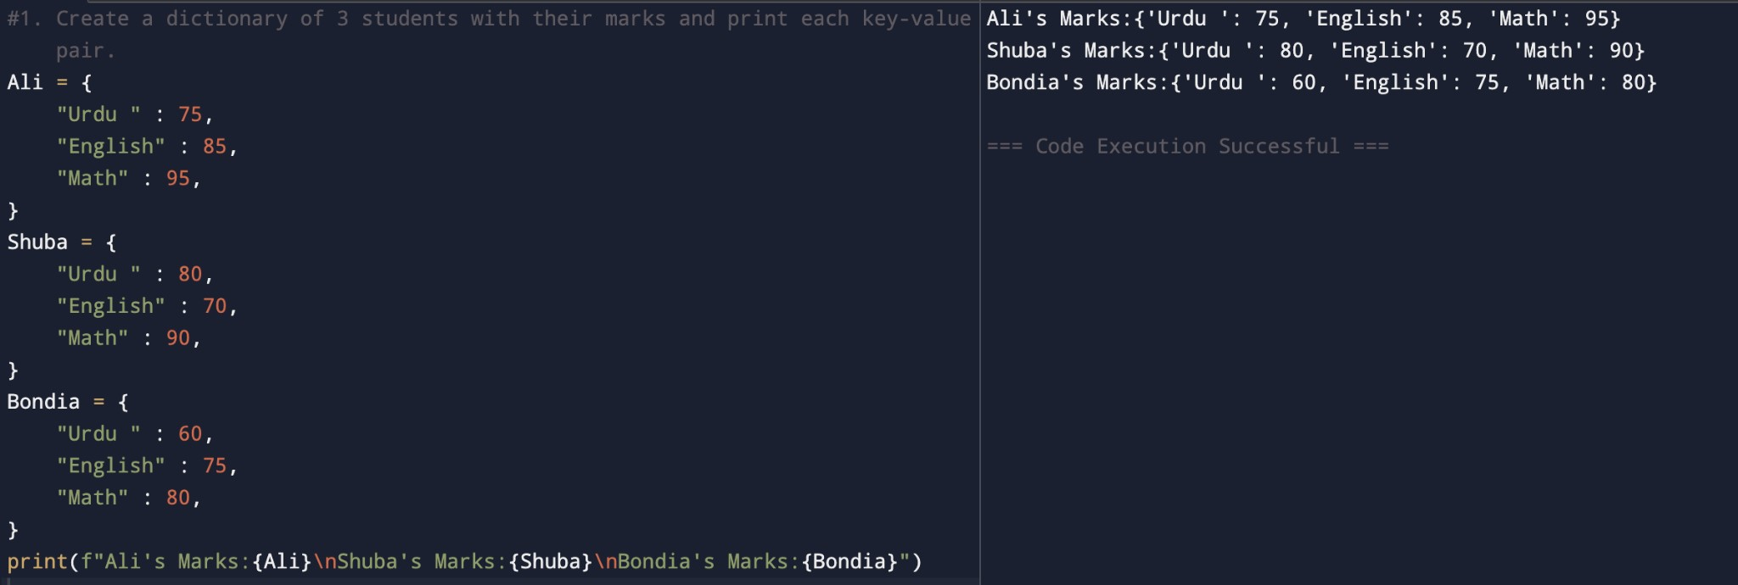
- Write a program to add a new key-value pair to a dictionary.
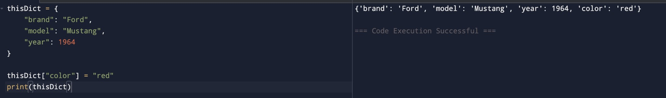
- WAP to Access a value from the dictionary using its key.
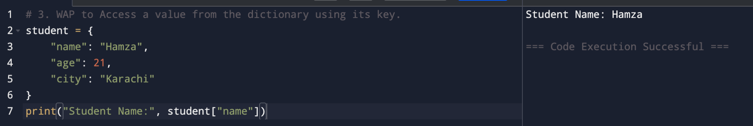
- WAP to Update an existing value in a dictionary.
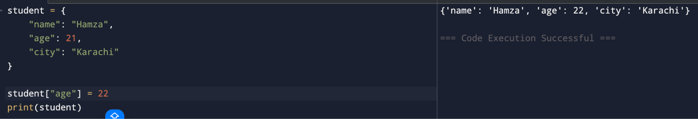
- WAP to Remove a key-value pair using pop() and del.
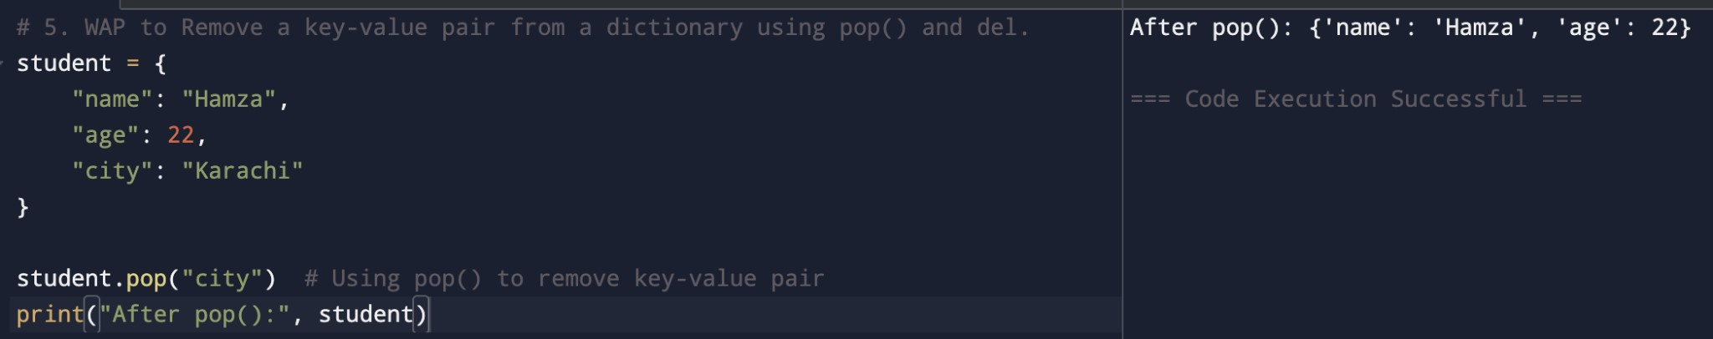
- Merge two dictionaries using the update() method.
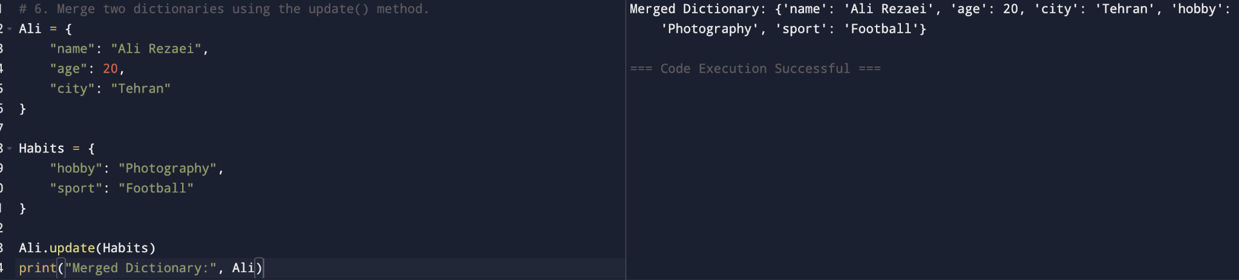
- Write a program that checks if a number entered by the user is positive, negative, or Zero.
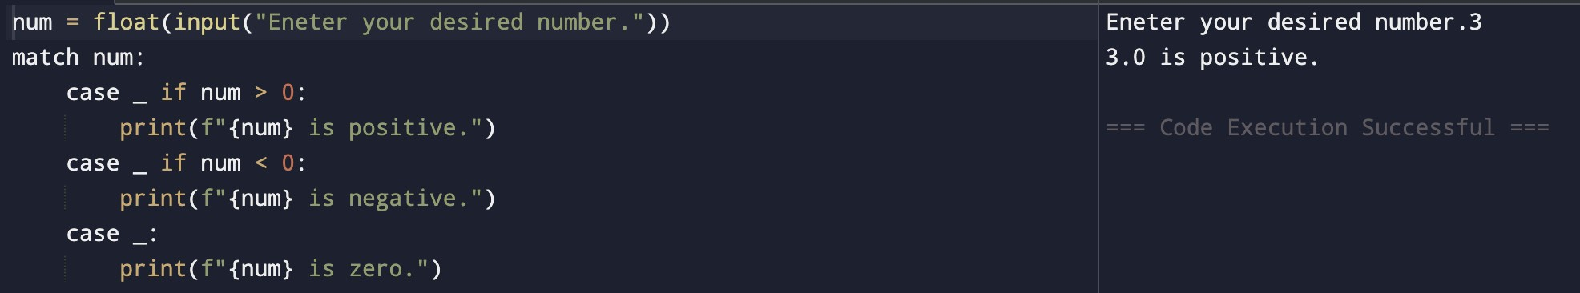
- Input three numbers and print the largest.
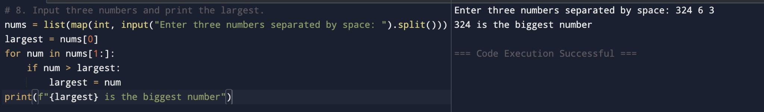
- Write a program to calculate a discount:
- If total ≥ 500, discount = 20%
- If total ≥ 200, discount = 10%
- Else no discount
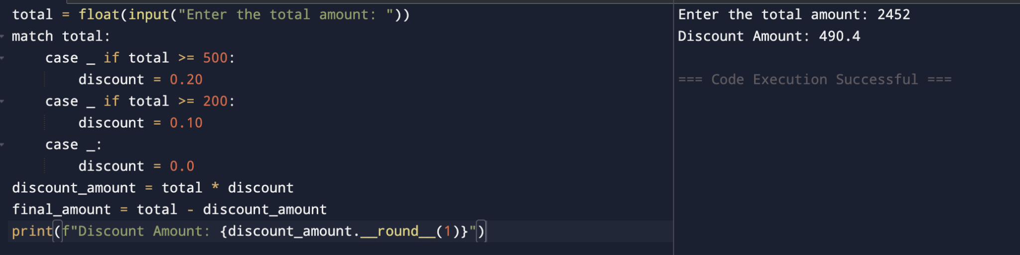
- Write a program to Ask for a username and password; allow login only if both are Correct.
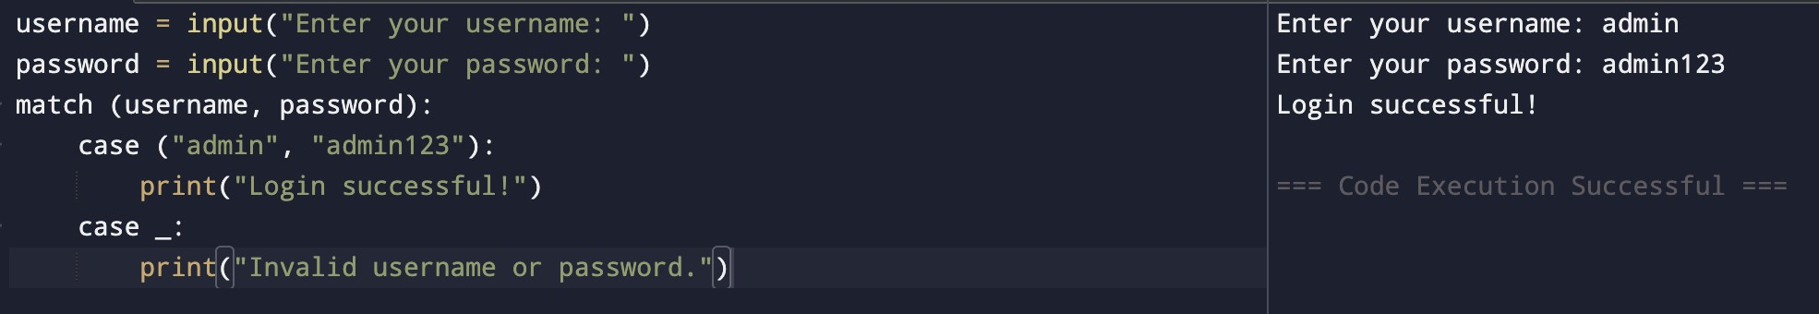
- Write a program to Ask the user for a password;
➢ If it's short (<6), print “Weak”, ➢ If medium (<10), print “Medium”, ➢ Else, print “Strong”.
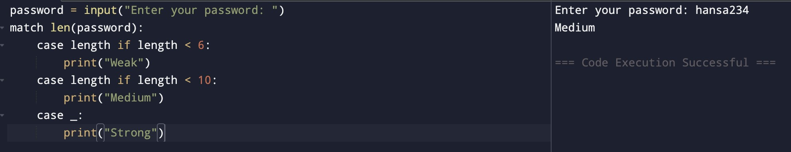
- Write a program to Ask for speed and determine whether to print No fine, Small fine, or Heavy fine.
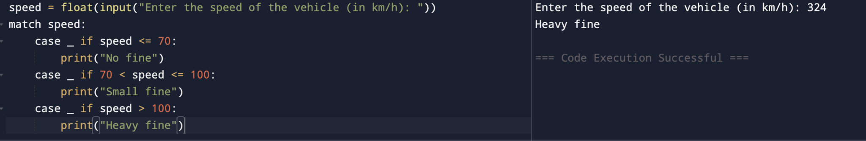
- A shop gives discounts which is :
- ≥1000 → 20%
- ≥500 → 10%
- <500 → no discount
Write a program to calculate final price.
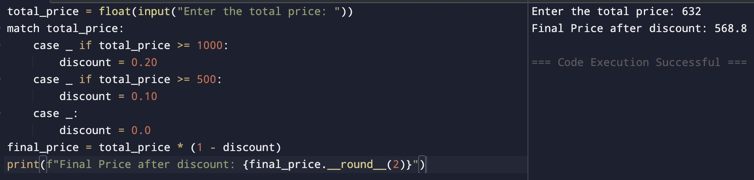
14. Write a program to Ask for temperature, humidity, and wind speed and classify the weather: ➢ Pleasant
- Normal
- Harsh
